***MY-SQL TASK***

DDL QUERIES:

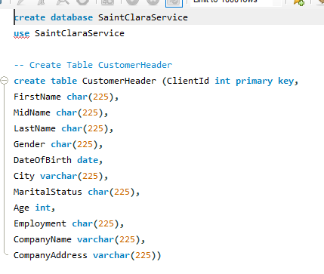***Starter Of Table***

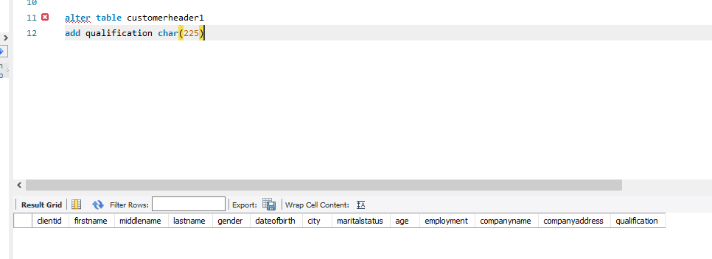***Table’S Of Queries:***

MODIFY QURIES:

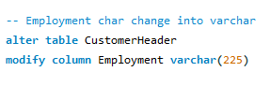

***ADD TABLE QUALIFICATION***

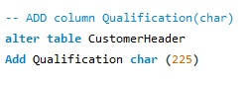

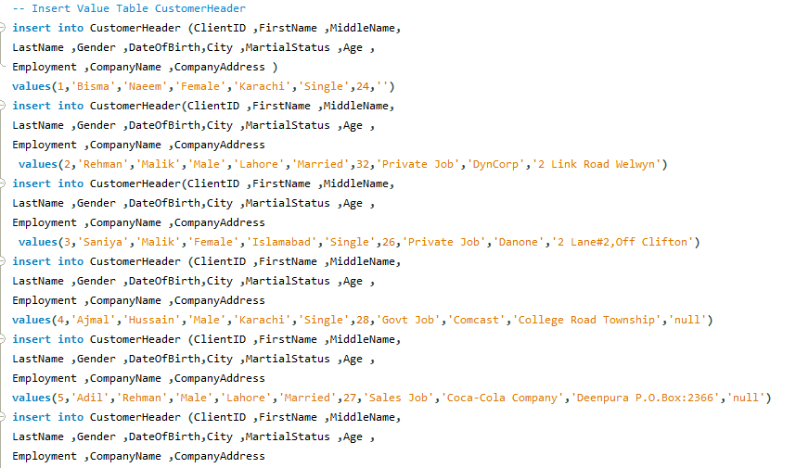***TABLE QURIES***

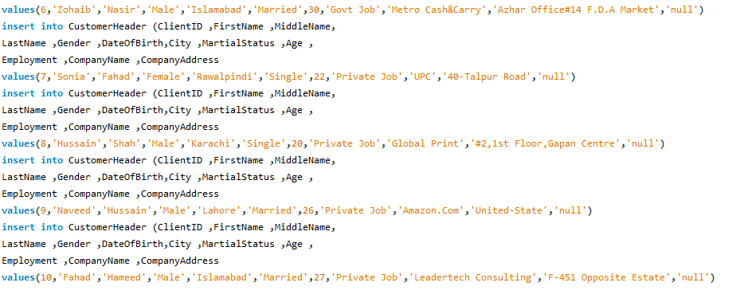

***TABLE STRUCTURE***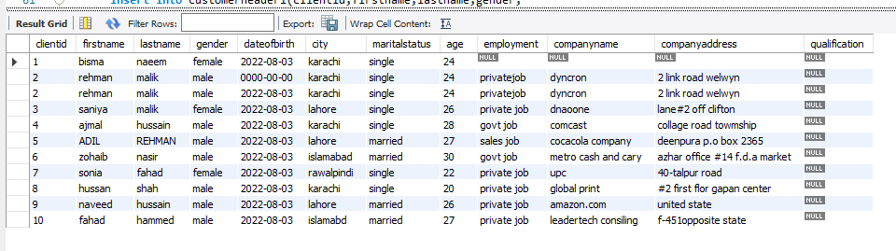

***UPDATE***



*TABLE 2*

DML QURIES

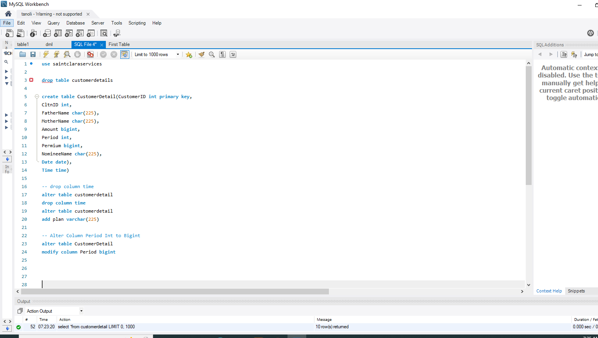

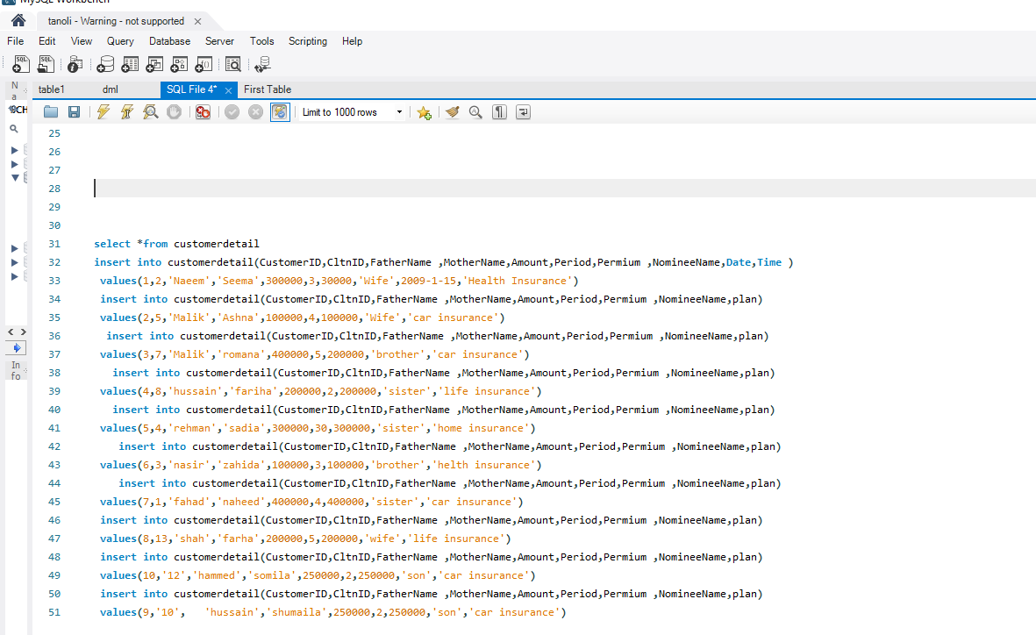

***TABLE STRUCTURE***

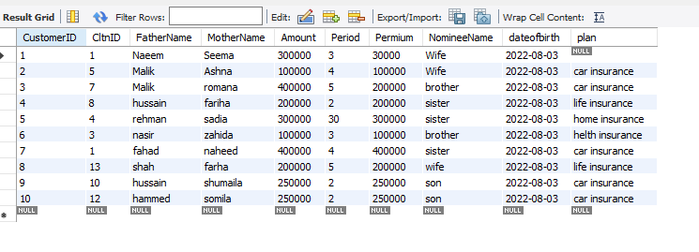

*****UPDATE***



----------------------------------FINALIZED-------------------------------------